***WEB TECHNOLOGIES PROJECT***

***Made by: Ankit Yadav***

**About my website*:***

***At EVERYTHING MART you get to enjoy our hassle free website interface and benefit from the features we provide.We at Everything mart aim at providing all kinds of apparel,fashion products at extravagantly discounted prices.Having our own AI designers and apparel creators who style your outfits according to your fits is our greatest feature .***

Html code

<!DOCTYPE html>

<html lang="en">

<head>

<meta charset="UTF-8" />

<meta name="viewport" content="width=device-width, initial-scale=1.0" />

<!-- Favicon -->

<link rel="shortcut icon" href="./images/favicon.ico" type="image/x-icon">

<!-- Box icons -->

<link rel="stylesheet" href="[https://cdn.jsdelivr.net/npm/boxicons@latest/cs](https://cdn.jsdelivr.net/npm/boxicons%40latest/cs) s/boxicons.min.css" />

<!-- Custom StyleSheet -->

<link rel="stylesheet" href="./css/styles.css" />

<title>Everything Mart - Shop with your Heart</title>

</head>

<body>

<!-- Header -->

<header id="home" class="header">

<!-- Navigation -->

<nav class="nav">

<div class="navigation container">

<div class="logo">

<h1>Everything Mart - Shop with your heart</h1>

</div>

<div class="menu">

<div class="top-nav">

<div class="logo">

<h1>Everything Mart</h1>

</div>

<div class="close">

<i class="bx bx-x"></i>

</div>

</div>

<ul class="nav-list">

<li class="nav-item">

<a href="#home" class="nav-link scroll-link">Home</a>

</li>

<li class="nav-item">

<a href="product.html" class="nav-link">Products</a>

</li>

<li class="nav-item">

<a href="#about" class="nav-link scroll-link">About us</a>

</li>

<li class="nav-item">

<a href="#contact" class="nav-link scroll-link">Contact us</a>

</li>

<li class="nav-item">

<a href="#account" class="nav-link scroll-link">Account</a>

</li>

<li class="nav-item">

<a href="cart.html" class="nav-link icon"><i class="bx bx- shopping-bag"></i></a>

</li>

</ul>

</div>

<a href="cart.html" class="cart-icon">

<i class="bx bx-shopping-bag"></i>

</a>

<div class="hamburger">

<i class="bx bx-menu"></i>

</div>

</div>

</nav>

<!-- Hero -->

<img src="./images/banner.jpg" alt="" class="hero-img" />

<div class="hero-content">

<h1>

<span>Summer is on</span>

<span>and so are we ! </span>

<small>Beat the Heat</small>

</h1>

<a class="btn" href="#">shop now</a>

</div>

</header>

<!-- Main -->

<main>

<section class="advert section">

<div class="advert-center container">

<div class="advert-box">

<div class="dotted">

<div class="content">

<h2>

Girls <br /> Clothing

</h2>

<h4>Worlds Best Brands</h4>

</div>

</div>

<img src="./images/advert1.png" alt="">

</div>

<div class="advert-box">

<div class="dotted">

<div class="content">

<h2>

Sports <br /> Clothing

</h2>

<h4>Wear the Best </h4>

</div>

</div>

<img src="./images/advert2.png" alt="">

</div>

<div class="advert-box">

<div class="dotted">

<div class="content">

<h2>

Boys <br /> Clothing

</h2>

<h4>Worlds Best Brands</h4>

</div>

</div>

<img src="./images/advert3.png" alt="">

</div>

</div>

</section>

<!-- Featured -->

<section class="section featured">

<div class="title">

<h1>Featured Products</h1>

</div>

<div class="product-center container">

<div class="product">

<div class="product-header">

<img src="./images/pic2.jpg" alt="">

<ul class="icons">

<span><i class="bx bx-heart"></i></span>

<span><i class="bx bx-shopping-bag"></i></span>

<span><i class="bx bx-search"></i></span>

</ul>

</div>

<div class="product-footer">

<a href="#">

<h3>Feel the Black</h3>

</a>

<div class="rating">

<i class="bx bxs-star"></i>

<i class="bx bxs-star"></i>

<i class="bx bxs-star"></i>

<i class="bx bxs-star"></i>

<i class="bx bx-star"></i>

</div>

<h4 class="price">From rs.150</h4>

</div>

</div>

<div class="product">

<div class="product-header">

<img src="./images/pic1.jpg" alt="">

<ul class="icons">

<span><i class="bx bx-heart"></i></span>

<span><i class="bx bx-shopping-bag"></i></span>

<span><i class="bx bx-search"></i></span>

</ul>

</div>

<div class="product-footer">

<a href="#"><h3>Branded Boy’s T-Shirts</h3></a>

<div class="rating">

<i class="bx bxs-star"></i>

<i class="bx bxs-star"></i>

<i class="bx bxs-star"></i>

<i class="bx bxs-star"></i>

<i class="bx bx-star"></i>

</div>

<h4 class="price">From rs.50</h4>

</div>

</div>

<div class="product">

<div class="product-header">

<img src="./images/pic3.jpg" alt="">

<ul class="icons">

<span><i class="bx bx-heart"></i></span>

<span><i class="bx bx-shopping-bag"></i></span>

<span><i class="bx bx-search"></i></span>

</ul>

</div>

<div class="product-footer">

<a href="#"><h3>Classic Hoodies</h3></a>

<div class="rating">

<i class="bx bxs-star"></i>

<i class="bx bxs-star"></i>

<i class="bx bxs-star"></i>

<i class="bx bxs-star"></i>

<i class="bx bx-star"></i>

</div>

<h4 class="price">From rs.80</h4>

</div>

</div>

<div class="product">

<div class="product-header">

<img src="./images/pic4.jpg" alt="">

<ul class="icons">

<span><i class="bx bx-heart"></i></span>

<span><i class="bx bx-shopping-bag"></i></span>

<span><i class="bx bx-search"></i></span>

</ul>

</div>

<div class="product-footer">

<a href="#"><h3>Premius Boy’s Lower</h3></a>

<div class="rating">

<i class="bx bxs-star"></i>

<i class="bx bxs-star"></i>

<i class="bx bxs-star"></i>

<i class="bx bxs-star"></i>

<i class="bx bx-star"></i>

</div>

<h4 class="price"> From rs.90</h4>

</div>

</div>

</div>

</section>

<!--Latest -->

<section class="section featured">

<div class="title">

<h1>Latest Products</h1>

</div>

<div class="product-center container">

<div class="product">

<div class="product-header">

<img src="./images/pic5.jpg" alt="">

<ul class="icons">

<span><i class="bx bx-heart"></i></span>

<span><i class="bx bx-shopping-bag"></i></span>

<span><i class="bx bx-search"></i></span>

</ul>

</div>

<div class="product-footer">

<a href="#"><h3>Black Sneakers</h3></a>

<div class="rating">

<i class="bx bxs-star"></i>

<i class="bx bxs-star"></i>

<i class="bx bxs-star"></i>

<i class="bx bxs-star"></i>

<i class="bx bx-star"></i>

</div>

<h4 class="price">rs.200</h4>

</div>

</div>

<div class="product">

<div class="product-header">

<img src="./images/pic6.png" alt="">

<ul class="icons">

<span><i class="bx bx-heart"></i></span>

<span><i class="bx bx-shopping-bag"></i></span>

<span><i class="bx bx-search"></i></span>

</ul>

</div>

<div class="product-footer">

<a href="#"><h3>Smart Watch</h3></a>

<div class="rating">

<i class="bx bxs-star"></i>

<i class="bx bxs-star"></i>

<i class="bx bx-star"></i>

</div>

<h4 class="price">rs.99</h4>

</div>

</div>

<div class="product">

<div class="product-header">

<img src="./images/pic7.jpg" alt="">

<ul class="icons">

<span><i class="bx bx-heart"></i></span>

<span><i class="bx bx-shopping-bag"></i></span>

<span><i class="bx bx-search"></i></span>

</ul>

</div>

<div class="product-footer">

<a href="#"><h3>The HRX socks (Pair of 3)</h3></a>

<div class="rating">

<i class="bx bxs-star"></i>

<i class="bx bxs-star"></i>

<i class="bx bx-star"></i>

</div>

<h4 class="price">rs.100</h4>

</div>

</div>

<div class="product">

<div class="product-header">

<img src="./images/pic8.jpg" alt="">

<ul class="icons">

<span><i class="bx bx-heart"></i></span>

<span><i class="bx bx-shopping-bag"></i></span>

<span><i class="bx bx-search"></i></span>

</ul>

</div>

<div class="product-footer">

<a href="#"><h3>Black Fossil Watch</h3></a>

<div class="rating">

<i class="bx bxs-star"></i>

<i class="bx bxs-star"></i>

<i class="bx bxs-star"></i>

<i class="bx bxs-star"></i>

<i class="bx bxs-star"></i>

</div>

<h4 class="price">rs.500</h4>

</div>

</div>

</div>

</section>

<!-- Product Banner -->

<section class="section">

<div class="product-banner">

<div class="left">

<img src="./images/test.jpg" alt="" />

</div>

<div class="right">

<div class="content">

<h2><span class="discount">50% </span> SALE OFF</h2>

<h1>

<span>Collect Your</span>

<span>Kids Collection</span>

</h1>

<a class="btn" href="#">shop now</a>

</div>

</div>

</div>

</section>

<!-- Brands -->

<section class="section">

<div class="brands-center container">

<div class="brand">

<img src="./images/brand1.png" alt="" />

</div>

<div class="brand">

<img src="./images/brand2.png" alt="" />

</div>

<div class="brand">

<img src="./images/brand3.png" alt="" />

</div>

<div class="brand">

<img src="./images/brand4.png" alt="" />

</div>

<div class="brand">

<img src="./images/brand5.png" alt="" />

</div>

<div class="brand">

<img src="./images/brand6.png" alt="" />

</div>

</div>

</section>

</main>

<!-- GSAP -->

<script src="https://cdnjs.cloudflare.com/ajax/libs/gsap/3.5.1/gsap.min.js">

</script>

<!-- Custom Script -->

<script src="./js/index.js"></script>

</body>

</html>

# Products.html

<!DOCTYPE html>

<html lang="en">

<head>

<meta charset="UTF-8" />

<meta name="viewport" content="width=device-width, initial-scale=1.0" />

<!-- Favicon -->

<link rel="shortcut icon" href="./images/favicon.ico" type="image/x-icon">

<!-- Box icons -->

<link rel="stylesheet" href="[https://cdn.jsdelivr.net/npm/boxicons@latest/](https://cdn.jsdelivr.net/npm/boxicons%40latest/) css/boxicons.min.css" />

<!-- Custom StyleSheet -->

<link rel="stylesheet" href="./css/styles.css" />

<title>Our Products</title>

</head>

<body>

<!-- Navigation -->

<nav class="nav">

<div class="navigation container">

<div class="logo">

<h1>Everything Mart</h1>

</div>

<div class="menu">

<div class="top-nav">

<div class="logo">

<h1>Everything Mart</h1>

</div>

<div class="close">

<i class="bx bx-x"></i>

</div>

</div>

<ul class="nav-list">

<li class="nav-item">

<a href="index.html" class="nav-link">Home</a>

</li>

<li class="nav-item">

<a href="product.html" class="nav-link">Products</a>

</li>

<li class="nav-item">

<a href="#about" class="nav-link">About</a>

</li>

<li class="nav-item">

<a href="#contact" class="nav-link">Contact</a>

</li>

<li class="nav-item">

<a href="account.html" class="nav-link">Account</a>

</li>

<li class="nav-item">

<a href="cart.html" class="nav- link icon"><i class="bx bx-shopping-bag"></i></a>

</li>

</ul>

</div>

<a href="cart.html" class="cart-icon">

<i class="bx bx-shopping-bag"></i>

</a>

<div class="hamburger">

<i class="bx bx-menu"></i>

</div>

</div>

</nav>

<!-- All Products -->

<section class="section all-products" id="products">

<div class="top container">

<h1>All Products</h1>

<form>

<select>

<option value="1">Default Sorting</option>

<option value="2">Sort By Price</option>

<option value="3">Sort By Popularity</option>

<option value="4">Sort By Sale</option>

<option value="5">Sort By Rating</option>

</select>

<span><i class='bx bx-chevron-down'></i></span>

</form>

</div>

<div class="product-center container">

<div class="product">

<div class="product-header">

<img src="./images/pic1.jpg" alt="">

<ul class="icons">

<span><i class="bx bx-heart"></i></span>

<a href="cart.html"> <span><i class="bx bx-shopping-

bag"></i></span>

</a>

<span><i class="bx bx-search"></i></span>

</ul>

</div>

<div class="product-footer">

<a href="product-details.html">

<h3>Premium Puma T-Shirt</h3>

</a>

<div class="rating">

<i class="bx bxs-star"></i>

<i class="bx bxs-star"></i>

<i class="bx bxs-star"></i>

<i class="bx bxs-star"></i>

<i class="bx bx-star"></i>

</div>

<h4 class="price">rs.150</h4>

</div>

</div>

<div class="product">

<div class="product-header">

<img src="./images/pic2.jpg" alt="">

<ul class="icons">

<span><i class="bx bx-heart"></i></span>

<span><i class="bx bx-shopping-bag"></i></span>

<span><i class="bx bx-search"></i></span>

</ul>

</div>

<div class="product-footer">

<h3>Black Puma T-Shirt</h3>

<div class="rating">

<i class="bx bxs-star"></i>

<i class="bx bxs-star"></i>

<i class="bx bxs-star"></i>

<i class="bx bxs-star"></i>

<i class="bx bx-star"></i>

</div>

<h4 class="price">rs.250</h4>

</div>

</div>

<div class="product">

<div class="product-header">

<img src="./images/pic3.jpg" alt="">

<ul class="icons">

<span><i class="bx bx-heart"></i></span>

<span><i class="bx bx-shopping-bag"></i></span>

<span><i class="bx bx-search"></i></span>

</ul>

</div>

<div class="product-footer">

<h3>Classic Hoodies</h3>

<div class="rating">

<i class="bx bxs-star"></i>

<i class="bx bxs-star"></i>

<i class="bx bxs-star"></i>

<i class="bx bxs-star"></i>

<i class="bx bx-star"></i>

</div>

<h4 class="price">rs.1500</h4>

</div>

</div>

<div class="product">

<div class="product-header">

<img src="./images/pic4.jpg" alt="">

<ul class="icons">

<span><i class="bx bx-heart"></i></span>

<span><i class="bx bx-shopping-bag"></i></span>

<span><i class="bx bx-search"></i></span>

</ul>

</div>

<div class="product-footer">

<h3>Cotton Lower</h3>

<div class="rating">

<i class="bx bxs-star"></i>

<i class="bx bxs-star"></i>

<i class="bx bxs-star"></i>

<i class="bx bxs-star"></i>

<i class="bx bx-star"></i>

</div>

<h4 class="price">rs.150</h4>

</div>

</div>

</div>

</section>

<section class="pagination">

<div class=" container">

<span>1</span>

<span>2</span>

<span>3</span>

<span>4</span>

<span><i class='bx bx-right-arrow-alt'></i></span>

</div>

</section>

<!-- GSAP -->

<script src="https://cdnjs.cloudflare.com/ajax/libs/gsap/3.5.1/gsap.min.js "></script>

<!-- Custom Script -->

<script src="./js/index.js"></script>

</body>

</html>

# Product-details.html

<!DOCTYPE html>

<html lang="en">

<head>

<meta charset="UTF-8" />

<meta name="viewport" content="width=device-width, initial-scale=1.0" />

<!-- Favicon -->

<link rel="shortcut icon" href="./images/favicon.ico" type="image/x-icon">

<!-- Box icons -->

<link rel="stylesheet" href="[https://cdn.jsdelivr.net/npm/boxicons@latest/cs](https://cdn.jsdelivr.net/npm/boxicons%40latest/cs) s/boxicons.min.css" />

<!-- Glidejs -->

<link rel="stylesheet" href="https://cdnjs.cloudflare.com/ajax/libs/Glide.js

/3.4.1/css/glide.core.css" />

<!-- Custom StyleSheet -->

<link rel="stylesheet" href="./css/styles.css" />

<title>Boy’s T-Shirt - Everthing Mart</title>

</head>

<body>

<!-- Navigation -->

<nav class="nav">

<div class="navigation container">

<div class="logo">

<h1>Everything Mart</h1>

</div>

<div class="menu">

<div class="top-nav">

<div class="logo">

<h1>Everything Mart</h1>

</div>

<div class="close">

<i class="bx bx-x"></i>

</div>

</div>

<ul class="nav-list">

<li class="nav-item">

<a href="index.html" class="nav-link">Home</a>

</li>

<li class="nav-item">

<a href="product.html" class="nav-link">Products</a>

</li>

<li class="nav-item">

<a href="#about" class="nav-link">About</a>

</li>

<li class="nav-item">

<a href="#contact" class="nav-link">Contact</a>

</li>

<li class="nav-item">

<a href="#account" class="nav-link">Account</a>

</li>

<li class="nav-item">

<a href="cart.html" class="nav-link icon"><i class="bx bx- shopping-bag"></i></a>

</li>

</ul>

</div>

<a href="cart.html" class="cart-icon">

<i class="bx bx-shopping-bag"></i>

</a>

<div class="hamburger">

<i class="bx bx-menu"></i>

</div>

</div>

</nav>

<!-- Product Details -->

<section class="section product-detail">

<div class="details container-md">

<div class="left">

<div class="main">

<img src="./images/pic1.jpg" alt="">

</div>

<div class="thumbnails">

<div class="thumbnail">

<img src="./images/pic1.jpg" alt="">

</div>

<div class="thumbnail">

<img src="./images/pic2.jpg" alt="">

</div>

<div class="thumbnail">

<img src="./images/pic3.jpg" alt="">

</div>

<div class="thumbnail">

<img src="./images/pic4.jpg" alt="">

</div>

</div>

</div>

<div class="right">

<span>Home/T-shirt</span>

<h1>Premium Puma T-shirt</h1>

<div class="price">rs.150</div>

<form>

<div>

<select>

<option value="Select Size" selected disabled>Select Size</optio

n>

<option value="1">32</option>

<option value="2">42</option>

<option value="3">52</option>

<option value="4">62</option>

</select>

<span><i class='bx bx-chevron-down'></i></span>

</div>

</form>

<form class="form">

<input type="text" placeholder="1">

<a href="cart.html" class="addCart">Add To Cart</a>

</form>

<h3>Product Detail</h3>

<p>100% Original Products <br>

Pay on delivery might be available <br> Easy 30 days returns and exchanges <br> Try & Buy might be available</p>

</div>

</div>

</section>

<!-- Related -->

<section class="section featured">

<div class="top container">

<h1>Products to go with this style</h1>

<a href="#" class="view-more">View more</a>

</div>

<div class="product-center container">

<div class="product">

<div class="product-header">

<img src="./images/pic8.jpg" alt="">

<ul class="icons">

<span><i class="bx bx-heart"></i></span>

<span><i class="bx bx-shopping-bag"></i></span>

<span><i class="bx bx-search"></i></span>

</ul>

</div>

<div class="product-footer">

<a href="#"><h3>Premium Watch</h3></a>

<div class="rating">

<i class="bx bxs-star"></i>

<i class="bx bxs-star"></i>

<i class="bx bxs-star"></i>

<i class="bx bxs-star"></i>

<i class="bx bx-star"></i>

</div>

<h4 class="price">rs.1150</h4>

</div>

</div>

<div class="product">

<div class="product-header">

<img src="./images/pic5.jpg" alt="">

<ul class="icons">

<span><i class="bx bx-heart"></i></span>

<span><i class="bx bx-shopping-bag"></i></span>

<span><i class="bx bx-search"></i></span>

</ul>

</div>

<div class="product-footer">

<a href="#"><h3>Black Shoes</h3></a>

<div class="rating">

<i class="bx bxs-star"></i>

<i class="bx bxs-star"></i>

<i class="bx bxs-star"></i>

</div>

<h4 class="price">rs.550</h4>

</div>

</div>

<div class="product">

<div class="product-header">

<img src="./images/pic6.png" alt="">

<ul class="icons">

<span><i class="bx bx-heart"></i></span>

<span><i class="bx bx-shopping-bag"></i></span>

<span><i class="bx bx-search"></i></span>

</ul>

</div>

<div class="product-footer">

<a href="#"><h3>Latest Smart Watch</h3></a>

<div class="rating">

<i class="bx bxs-star"></i>

<i class="bx bxs-star"></i>

<i class="bx bxs-star"></i>

<i class="bx bx-star"></i>

</div>

<h4 class="price">rs.1155</h4>

</div>

</div>

<div class="product">

<div class="product-header">

<img src="./images/pic7.jpg" alt="">

<ul class="icons">

<span><i class="bx bx-heart"></i></span>

<span><i class="bx bx-shopping-bag"></i></span>

<span><i class="bx bx-search"></i></span>

</ul>

</div>

<div class="product-footer">

<a href="#"><h3>HRX Pair of 3 Socks</h3></a>

<div class="rating">

<i class="bx bxs-star"></i>

<i class="bx bxs-star"></i>

<i class="bx bx-star"></i>

</div>

<h4 class="price">rs.150</h4>

</div>

</div>

</div>

</section>

<!-- GSAP -->

<script src="https://cdnjs.cloudflare.com/ajax/libs/gsap/3.5.1/gsap.min.js">

</script>

<!-- Custom Script -->

<script src="./js/index.js"></script>

</body>

</html>

# Cart.html

<!DOCTYPE html>

<html lang="en">

<head>

<meta charset="UTF-8" />

<meta name="viewport" content="width=device-width, initial-scale=1.0" />

<!-- Favicon -->

<link rel="shortcut icon" href="./images/favicon.ico" type="image/x-icon">

<!-- Box icons -->

<link rel="stylesheet" href="[https://cdn.jsdelivr.net/npm/boxicons@latest/cs](https://cdn.jsdelivr.net/npm/boxicons%40latest/cs) s/boxicons.min.css" />

<!-- Custom StyleSheet -->

<link rel="stylesheet" href="./css/styles.css" />

<title>Your Cart</title>

</head>

<body>

<!-- Navigation -->

<nav class="nav">

<div class="navigation container">

<div class="logo">

<h1>Everything Mart - Shop with your Heart</h1>

</div>

<div class="menu">

<div class="top-nav">

<div class="logo">

<h1>Everything Mart - Shop with your Heart</h1>

</div>

<div class="close">

<i class="bx bx-x"></i>

</div>

</div>

<ul class="nav-list">

<li class="nav-item">

<a href="index.html" class="nav-link">Home</a>

</li>

<li class="nav-item">

<a href="product.html" class="nav-link">Products</a>

</li>

<li class="nav-item">

<a href="#about" class="nav-link">About</a>

</li>

<li class="nav-item">

<a href="#contact" class="nav-link">Contact</a>

</li>

<li class="nav-item">

<a href="#contact" class="nav-link">Account</a>

</li>

<li class="nav-item">

<a href="cart.html" class="nav-link icon"><i class="bx bx- shopping-bag"></i></a>

</li>

</ul>

</div>

<a href="cart.html" class="cart-icon">

<i class="bx bx-shopping-bag"></i>

</a>

<div class="hamburger">

<i class="bx bx-menu"></i>

</div>

</div>

</nav>

<!-- Cart Items -->

<div class="container-md cart">

<table>

<tr>

<th>Product</th>

<th>Quantity</th>

<th>Subtotal</th>

</tr>

<tr>

<td>

<div class="cart-info">

<img src="./images/pic1.jpg" alt="">

<div>

<p>Premium Puma T-Shirt</p>

<span>Price: rs.50.00</span>

<br />

<a href="#">remove</a>

</div>

</div>

</td>

<td><input type="number" value="1" min="1"></td>

<td>rs.50.00</td>

</tr>

<tr>

<td>

<div class="cart-info">

<img src="./images/pic2.jpg" alt="">

<div>

<p>Black T-Shirt</p>

<span>Price: rs.90.00</span>

<br />

<a href="#">remove</a>

</div>

</div>

</td>

<td><input type="number" value="1" min="1"></td>

<td>rs.90.00</td>

</tr>

</table>

<div class="total-price">

<table>

<tr>

<td>Subtotal</td>

<td>rs.140</td>

</tr>

<tr>

<td>Tax</td>

<td>rs.50</td>

</tr>

<tr>

<td>Total</td>

<td>rs.190</td>

</tr>

</table>

<a href="#" class="checkout btn">Proceed To Checkout</a>

</div>

</div>

<!-- GSAP -->

<script src="https://cdnjs.cloudflare.com/ajax/libs/gsap/3.5.1/gsap.min.js">

</script>

<!-- Custom Script -->

<script src="./js/index.js"></script>

</body>

</html>

# Index.js

const menu = document.querySelector(".menu");

const navOpen = document.querySelector(".hamburger"); const navClose = document.querySelector(".close");

const navLeft = menu.getBoundingClientRect().left; navOpen.addEventListener("click", () => {

if (navLeft < 0) { menu.classList.add("show"); document.body.classList.add("show"); navBar.classList.add("show");

}

});

navClose.addEventListener("click", () => { if (navLeft < 0) {

menu.classList.remove("show"); document.body.classList.remove("show"); navBar.classList.remove("show");

}

});

// Fixed Nav

const navBar = document.querySelector(".nav");

const navHeight = navBar.getBoundingClientRect().height; window.addEventListener("scroll", () => {

const scrollHeight = window.pageYOffset; if (scrollHeight > navHeight) {

navBar.classList.add("fix-nav");

} else {

navBar.classList.remove("fix-nav");

}

});

// Scroll To

const links = [...document.querySelectorAll(".scroll-link")]; links.map(link => {

if (!link) return; link.addEventListener("click", e => {

e.preventDefault();

const id = e.target.getAttribute("href").slice(1); const element = document.getElementById(id);

const fixNav = navBar.classList.contains("fix-nav"); let position = element.offsetTop - navHeight;

window.scrollTo({ top: position, left: 0,

});

navBar.classList.remove("show"); menu.classList.remove("show"); document.body.classList.remove("show");

});

});

gsap.from(".logo", { opacity: 0, duration: 1, delay: 0.5, y: -10 });

gsap.from(".hamburger", { opacity: 0, duration: 1, delay: 1, x: 20 });

gsap.from(".hero-img", { opacity: 0, duration: 1, delay: 1.5, x: -200 });

gsap.from(".hero-content h2", { opacity: 0, duration: 1, delay: 2, y: -50 }); gsap.from(".hero-content h1", { opacity: 0, duration: 1, delay: 2.5, y: -

45 });

gsap.from(".hero-content a", { opacity: 0, duration: 1, delay: 3.5, y: 50 });

styles.css

:root {

--white: #fff;

--black: #222;

--pink: #f60091;

--grey: #444;

--grey2: #959595;

--grey-alt: #d1e2e9;

--yellow: #ffd800;

--green: #59b210;

}

*,

*::before,

*::after { margin: 0;

padding: 0;

box-sizing: inherit;

}

html {

scroll-behavior: smooth; box-sizing: border-box; font-size: 62.5%;

}

body {

font-family: "Poppins", sans-serif; font-size: 1.6rem;

font-weight: 400; background-color: #fff; color: #243a6f; position: relative;

z-index: 1;

}

h1,

h2,

h3,

h4 {

font-weight: 500;

}

a {

color: inherit;

text-decoration: none;

}

img {

max-width: 100%;

}

li {

list-style: none;

}

.container {

max-width: 120rem; margin: 0 auto;

}

.container-md {

max-width: 100rem; margin: 0 auto;

}

@media only screen and (max-width: 1200px) {

.container { padding: 0 3rem;

}

.container-md { padding: 0 3rem;

}

}

/* Header */

.header {

position: relative; width: 100%;

min-height: 100vh;

background-color: var(--grey-alt); overflow: hidden;

}

.nav {

padding: 1.6rem 0;

}

.nav.fix-nav { position: fixed; top: 0;

left: 0;

width: 100%;

background-color: #243a6f;

box-shadow: 0 5px 15px rgba(0, 0, 0, 0.3);

z-index: 999;

}

.nav.fix-nav .nav-link,

.nav.fix-nav .logo,

.nav.fix-nav .cart-icon,

.nav.fix-nav .hamburger { color: #fff;

}

.navigation { display: flex;

align-items: center;

justify-content: space-between;

}

.logo h1 {

font-size: 2.5rem;

}

.nav-list { display: flex;

align-items: center;

}

.nav-item:not(:last-child) { margin-right: 0.5rem;

}

.nav-link:link,

.nav-link:visited { padding: 0.8rem 1rem;

transition: all 300ms ease-in-out;

}

.nav-link.icon { font-size: 3rem;

}

.top-nav { display: none;

}

.hamburger { display: none;

}

.cart-icon { display: none;

}

@media only screen and (max-width: 768px) {

.menu {

position: fixed; top: 0;

left: -100%;

width: 80%;

max-width: 40rem; height: 100%; background-color: #fff;

transition: all 500ms ease-in-out; z-index: 100;

}

.menu.show { left: 0;

}

.top-nav { display: flex;

align-items: center;

justify-content: space-between; background-color: #243a6f; padding: 1rem 1.6rem;

}

.top-nav .logo { color: #fff;

}

.top-nav .close { color: #fff; font-size: 3rem; padding: 1rem; cursor: pointer;

}

.cart-icon { display: block; font-size: 3rem;

}

.hamburger { display: block; font-size: 3rem; padding: 0.5rem; cursor: pointer;

}

.nav-link:link,

.nav-link:visited { display: block; font-size: 1.7rem; padding: 1rem 0;

}

.nav.fix-nav .nav-link { color: #243a6f;

}

.nav-list {

flex-direction: column; align-items: start; padding: 1rem 1.6rem;

}

body.show::before { content: ""; position: absolute; top: 0;

left: 0;

width: 100%;

height: 100%;

background-color: rgba(0, 0, 0, 0.8);

z-index: 4;

}

.nav.show {

background-color: rgba(0, 0, 0, 0.8);

}

.nav-link.icon { display: none;

}

}

/* Hero */

.header .hero-img { position: absolute; bottom: -10%;

right: -5%; height: 70rem;

object-fit: contain;

}

.hero-content { position: absolute; top: 50%;

transform: translate(25%, -50%);

}

.hero-content h2 { color: #b888ff;

font-size: 3rem; font-weight: 700; margin-bottom: 1rem;

}

.hero-content .discount { color: #fbb419;

}

.hero-content h1 span { color: #253b70;

font-size: 6rem; font-weight: 700; display: block; line-height: 1;

text-shadow: 3px 3px 0 #f1f1f1, 4px 4px 0 #f1f1f1;

}

.btn {

display: inline-block; background-color: #fc7c7c; padding: 1.2rem 4rem; color: #fff;

font-weight: 600;

text-transform: uppercase; margin-top: 3rem;

}

@media only screen and (max-width: 1200px) {

.header .hero-img { right: -20%;

}

.hero-content {

transform: translate(20%, -50%);

}

.hero-content h2 { font-size: 2rem;

}

.hero-content h1 span { font-size: 5rem;

}

}

@media only screen and (max-width: 996px) {

.header {

min-height: 70vh;

}

.header .hero-img { height: 40rem; right: -10%;

}

}

@media only screen and (max-width: 567px) {

.header {

min-height: 100vh;

}

.header .hero-img { height: 40rem; bottom: -15%;

}

.hero-content { top: 40%;

transform: translate(15%, -50%);

}

.header .hero-img { right: 0%;

}

.hero-content h2 { font-size: 1.8rem;

}

.hero-content h1 span { font-size: 4rem;

}

.hero-content a { padding: 1rem 3rem;

}

}

/* Adverts */

.section {

padding: 10rem 0 5rem 0;

}

.advert-center { display: grid;

grid-template-columns: repeat(auto-fit, minmax(30rem, 1fr)); gap: 3rem;

}

.advert-box { position: relative; color: #fff; height: 27rem;

border-radius: 1rem; padding: 1.6rem; overflow: hidden;

z-index: 1;

}

.advert-box img { position: absolute; bottom: 0%;

left: -20%;

height: 100%; width: 35rem; z-index: -1;

}

.advert-box:nth-child(1) { background-color: #f5c5d1;

}

.advert-box:nth-child(2) { background-color: #a1d1df;

}

.advert-box:nth-child(3) { background-color: #e5bc00;

}

.advert-box .dotted { position: relative; height: 100%;

border: 2px dashed #f1f1f1; border-radius: 1rem;

}

.advert-box .content { position: absolute; top: 50%;

right: 5%;

transform: translate(0, -50%);

}

.advert-box .content h2,

.advert-box .content h4 {

text-shadow: 5px 6px 0px rgba(37, 59, 112, 0.1);

}

.advert-box .content h2 { line-height: 1.2;

font-size: 3rem; font-weight: 700; margin-bottom: 1rem;

}

.advert-box .content h4 { font-size: 1.5rem;

text-transform: capitalize;

}

/* Featured Products */

.title {

margin: 4rem 0 7rem 0; text-align: center;

}

.title h1 {

font-size: 3rem; display: inline-block; position: relative;

z-index: 0;

}

.title h1::after { content: ""; position: absolute; left: 50%;

bottom: -20%;

transform: translate(-50%, -50%); background-color: var(--pink); width: 50%;

height: 0.4rem; z-index: 1;

}

/* Product */

.product-center { display: grid;

grid-template-columns: repeat(auto-fit, minmax(25rem, 1fr));

gap: 7rem 3rem;

}

.product { height: 48rem;

background-color: #fff;

box-shadow: 0 0.5rem 1.5rem rgba(0, 0, 0, 0.15); border-radius: 1rem;

text-align: center;

transition: all 300ms ease-in-out;

}

.product:hover {

box-shadow: 0 0.5rem 1.5rem rgba(0, 0, 0, 0.25);

}

.product-header { position: relative; height: 35rem;

background-color: #f6f2f1; transition: all 300ms ease-in-out; z-index: 0;

}

.product-header img { height: 100%;

}

.product-footer {

padding: 2rem 1.6rem 1.6rem 1.6rem;

}

.product-footer h3 { font-size: 2.2rem;

}

.rating {

color: #43b3d9;

}

.product-footer .price { color: #ff7c9c;

font-size: 2rem;

}

.product:hover .product-header::after { content: "";

position: absolute;

width: 100%;

height: 100%;

left: 0;

top: 0;

border-radius: 1rem 1rem 0 0;

background-color: rgba(0, 0, 0, 0.5); transition: all 500ms ease-in-out;

z-index: 1;

}

.product-header .icons { position: absolute; right: 5%;

top: 50%;

transform: translate(0, -50%) scale(0); z-index: 2;

opacity: 0;

transition: all 500ms ease-in-out;

}

.product-header .icons span { background-color: #fff; font-size: 2.5rem;

display: block; border-radius: 50%;

padding: 1.5rem 1.6rem; line-height: 2rem; cursor: pointer;

transition: all 300ms ease-in-out;

}

.product-header .icons span i { transition: all 500ms ease-in-out;

}

.product-header .icons span:not(:last-child) { margin-bottom: 1rem;

}

.product-header .icons span:hover { background-color: #ff7c9c;

color: #fff;

}

.product:hover .icons { opacity: 1;

transform: translate(0, -50%) scale(1);

}

.product-header .icons a { display: block;

margin-bottom: 1rem;

}

/* Exclusive Product */

.product-banner { display: grid;

grid-template-columns: 1fr 1fr; height: 50rem;

background-color: #243a6f;

}

.product-banner .left img { object-fit: cover; height: 100%;

}

.product-banner .right { align-self: center; text-align: center; padding: 1.6rem;

}

.product-banner .content h2 { color: #fbb419;

font-size: 3rem; font-weight: 700; margin-bottom: 1rem;

}

.product-banner .content .discount { color: #b888ff;

}

.product-banner .content h1 span { color: #fff;

font-size: 6rem; font-weight: 700; display: block; line-height: 1;

}

@media only screen and (max-width: 996px) {

.product-banner .content h1 span { font-size: 5rem;

}

}

@media only screen and (max-width: 768px) {

.product-banner {

grid-template-columns: 1fr;

}

.product-banner .left { display: none;

}

.product-banner .content h1 span { font-size: 4rem;

}

.product-banner .content h2 { font-size: 2rem;

}

.product-banner .content a { padding: 1rem 3rem;

}

}

/* Testimonials */

.testimonial-center { display: grid;

grid-template-columns: repeat(auto-fit, minmax(25rem, 1fr)); gap: 6rem;

}

.testimonial { position: relative; padding: 5rem;

background-color: #fff;

box-shadow: 0 0.5rem 1.5rem rgba(0, 0, 0, 0.1); transition: all 300ms ease-in-out;

text-align: center; border-radius: 0.5rem;

}

.testimonial:hover {

box-shadow: 0 0.5rem 1.5rem rgba(0, 0, 0, 0.2); transform: translateY(-1rem);

}

.testimonial span { position: absolute;

top: 2%;

left: 50%;

font-size: 12rem;

font-family: sans-serif; color: #ff7c9c;

line-height: 1;

transform: translate(-50%, 0);

}

.testimonial p {

margin: 2rem 0 1rem 0;

}

.testimonial .rating { margin-bottom: 1rem;

}

.testimonial .img-cover { border-radius: 50%; width: 8rem;

height: 8rem; overflow: hidden; margin: 0 auto;

}

.testimonial .img-cover img { height: 100%;

object-fit: cover;

}

.testimonial h4 { margin-top: 1rem;

}

/* Brands */

.brands-center { display: grid;

grid-template-columns: repeat(6, 1fr); gap: 3rem;

}

.brand { height: 8rem; width: 8rem;

margin: 0 auto;

}

.brand img {

object-fit: contain;

}

@media only screen and (max-width: 768px) {

.brands-center {

grid-template-columns: repeat(3, 1fr);

}

}

/* ========= Footer ======== */

.footer {

background-color: var(--black); padding: 6rem 1rem;

line-height: 3rem;

}

.footer-center span { margin-right: 1rem;

}

.footer-container { display: grid;

grid-template-columns: repeat(4, 1fr); color: var(--white);

}

.footer-center a:link,

.footer-center a:visited { display: block;

color: #f1f1f1; font-size: 1.4rem; transition: 0.6s;

}

.footer-center a:hover { color: var(--pink);

}

.footer-center div { color: #f1f1f1; font-size: 1.4rem;

}

.footer-center h3 { font-size: 1.8rem; font-weight: 400; margin-bottom: 1rem;

}

@media only screen and (max-width: 998px) {

.footer-container {

grid-template-columns: repeat(2, 1fr); row-gap: 2rem;

}

}

@media only screen and (max-width: 768px) {

.footer-container {

grid-template-columns: 1fr; row-gap: 2rem;

}

}

/* All Products */

.section .top { display: flex;

align-items: center;

justify-content: space-between; margin-bottom: 4rem;

}

.all-products .top select {

font-family: "Poppins", sans-serif; width: 20rem;

padding: 1rem;

border: 1px solid #ccc; appearance: none; outline: none;

}

form {

position: relative; z-index: 1;

}

form span {

position: absolute; top: 50%;

right: 1rem;

transform: translateY(-50%); font-size: 2rem;

z-index: 0;

}

@media only screen and (max-width: 768px) {

.all-products .top select {

width: 15rem;

}

}

/* Pagination */

.pagination {

padding: 3rem 0 5rem 0;

}

.pagination span { display: inline-block; padding: 1rem 1.5rem;

border: 1px solid #243a6f; font-size: 1.8rem;

margin-bottom: 2rem; cursor: pointer;

transition: all 300ms ease-in-out;

}

.pagination span:hover { border: 1px solid #243a6f; background-color: #243a6f; color: #fff;

}

/* Detail */

.product-detail .details { display: grid;

grid-template-columns: 1fr 1.2fr; gap: 7rem;

}

.product-detail .left { display: flex;

flex-direction: column;

}

.product-detail .left .main { text-align: center; background-color: #f6f2f1; margin-bottom: 2rem; height: 45rem;

padding: 3rem;

}

.product-detail .left .main img { object-fit: contain;

height: 100%;

}

.product-detail .thumbnails { display: grid;

grid-template-columns: repeat(4, 1fr); gap: 1rem;

}

.product-detail .thumbnail { width: 10rem;

height: 10rem;

background-color: #f6f2f1; text-align: center;

}

.product-detail .thumbnail img { height: 100%;

object-fit: contain;

}

.product-detail .right span { display: inline-block; font-size: 1.5rem;

margin-bottom: 1rem;

}

.product-detail .right h1 { font-size: 4rem;

line-height: 1.2; margin-bottom: 2rem;

}

.product-detail .right .price { font-size: 600;

font-size: 2rem; color: #ff7c9c; margin-bottom: 2rem;

}

.product-detail .right div { display: inline-block; position: relative;

z-index: 1;

}

.product-detail .right select {

font-family: "Poppins", sans-serif; width: 20rem;

padding: 0.7rem; border: 1px solid #ccc; appearance: none; outline: none;

}

.product-detail form { margin-bottom: 2rem;

}

.product-detail form span { position: absolute;

top: 50%; right: 1rem;

transform: translateY(-50%); font-size: 2rem;

z-index: 0;

}

.product-detail .form { margin-bottom: 3rem;

}

.product-detail .form input { padding: 0.8rem;

text-align: center; width: 3.5rem; margin-right: 2rem;

}

.product-detail .form .addCart { background: #ff7c9c;

padding: 0.8rem 4rem; color: #fff;

border-radius: 3rem;

}

.product-detail h3 {

text-transform: uppercase; margin-bottom: 2rem;

}

@media only screen and (max-width: 996px) {

.product-detail .left { width: 30rem;

height: 45rem;

}

.product-detail .details { gap: 3rem;

}

.product-detail .thumbnails { width: 30rem;

gap: 0.5rem;

}

.product-detail .thumbnail { width: auto;

height: 10rem;

background-color: #f6f2f1; text-align: center; padding: 0.5rem;

}

}

@media only screen and (max-width: 650px) {

.product-detail .details { grid-template-columns: 1fr;

}

.product-detail .right { margin-top: 10rem;

}

.product-detail .left { width: 100%;

height: 45rem;

}

.product-detail .details { gap: 3rem;

}

.product-detail .thumbnails { width: 100%;

gap: 0.5rem;

}

}

/* Cart Items */

.cart {

margin: 10rem auto;

}

table {

width: 100%;

border-collapse: collapse;

}

.cart-info { display: flex; flex-wrap: wrap;

}

th {

text-align: left; padding: 0.5rem; color: #fff;

background-color: #fc7c7c; font-weight: normal;

}

td {

padding: 1rem 0.5rem;

}

td input { width: 5rem; height: 3rem;

padding: 0.5rem;

}

td a {

color: orangered; font-size: 1.4rem;

}

td img { width: 8rem;

height: 8rem; margin-right: 1rem;

}

.total-price { display: flex;

justify-content: flex-end; align-items: end;

flex-direction: column; margin-top: 2rem;

}

.total-price table {

border-top: 3px solid #fc7c7c;

width: 100%;

max-width: 35rem;

}

td:last-child { text-align: right;

}

th:last-child { text-align: right;

}

@media only screen and (max-width: 567px) {

.cart-info p { display: none;

}

}

**OUTPUT WEBSITE:**

**HOMEPAGE**

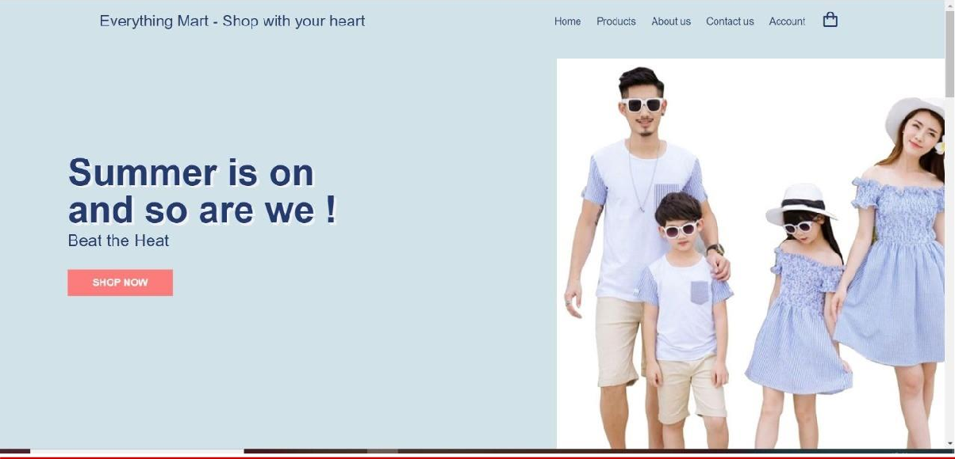

**PRODUCTS PAGE**

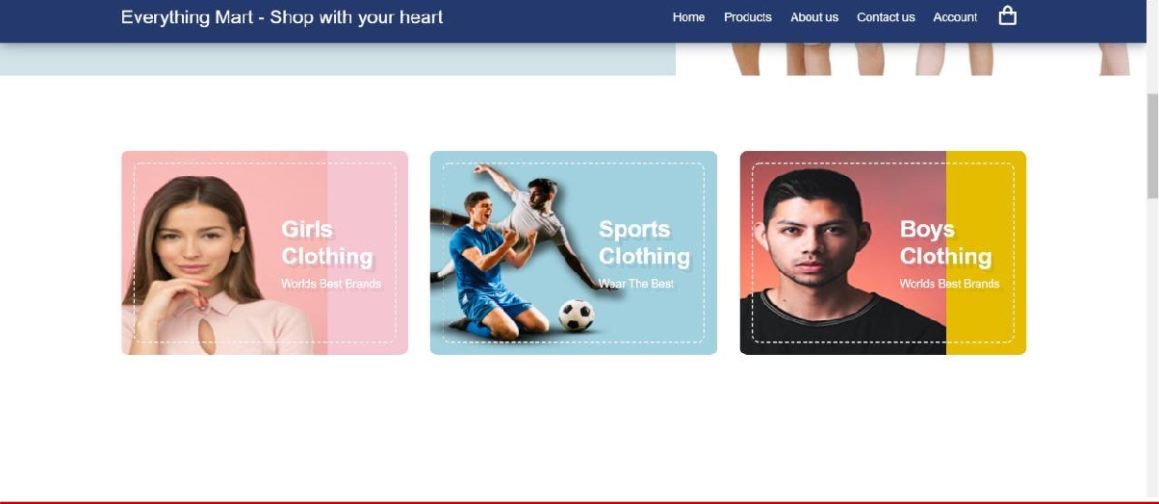

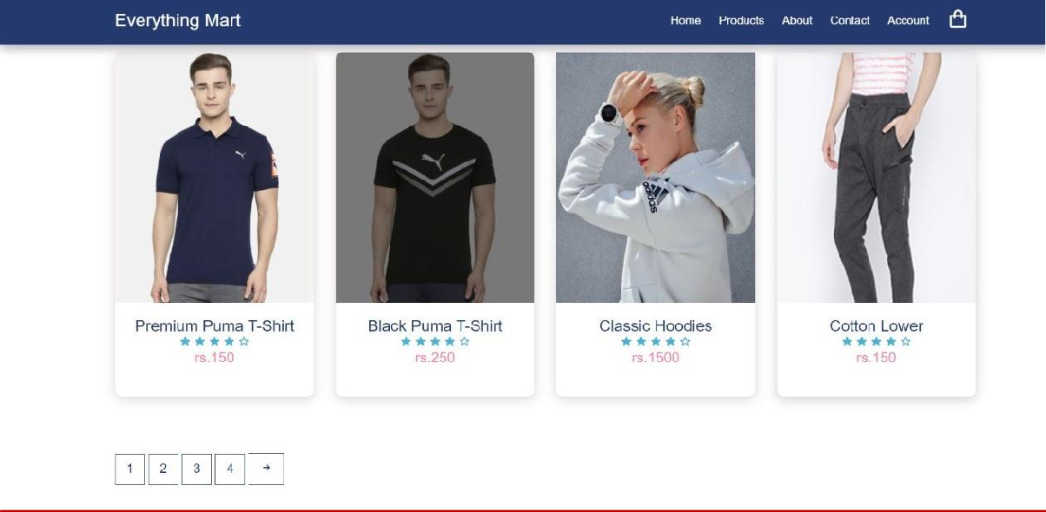

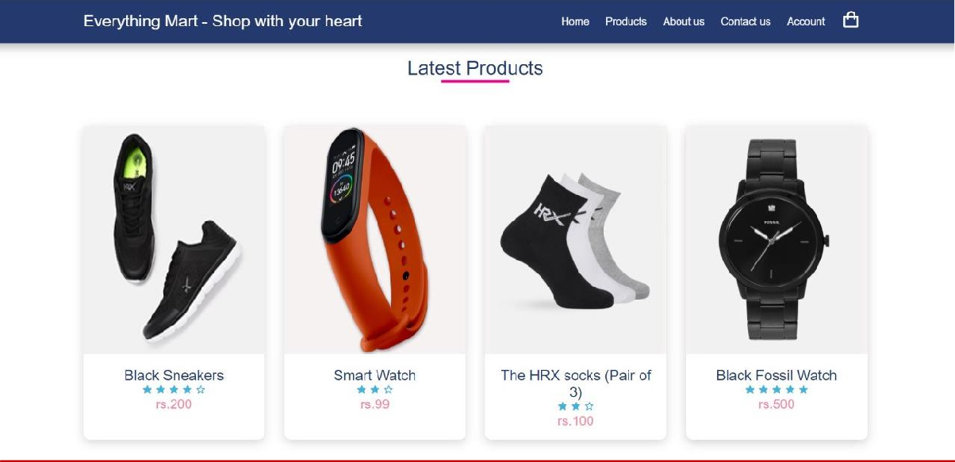

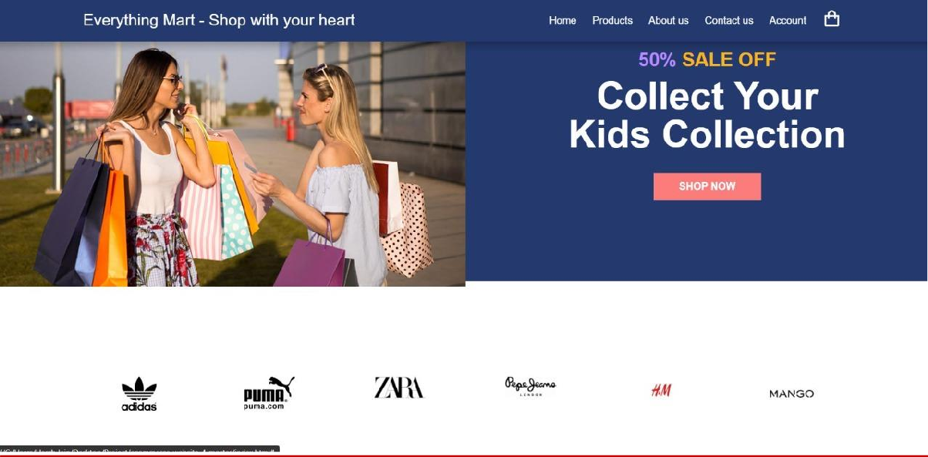

Everything Mart

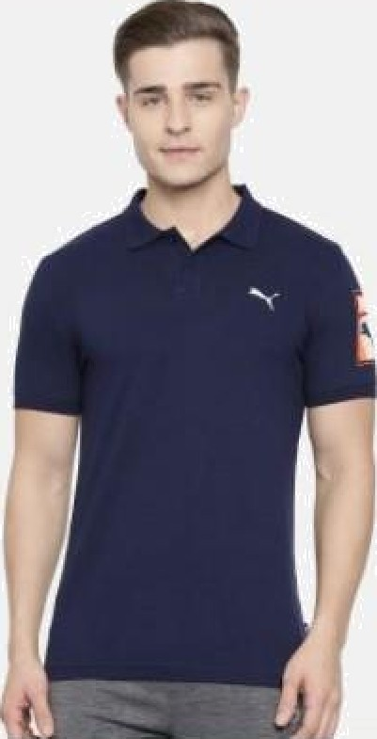

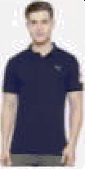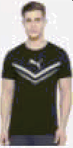

Everything Marl - Shop with your Hearl

Home Products About Contact Account

Home/’T-shirt

Premium Puma T- shirt

Select Size

PRODUCT DETAIL

100%o Original Products

Pay on delivery might be available Easy 30 days returns and exchanges Try & Buy might be available

